**PROTOCOL FOR PREPARATION OF SOLUTIONS, CALCULATION OF MOLARITY, AND SOLUTION PREPARATION.**

***Versión 1.0***

**Produced by: Angélica María Pineda Saza**

# OBJE**CTIVE**

The objective of this protocol is to instruct the extraction of chlorophyll in plant tissues and the preparation of solvents.

# SCOPE

Develop techniques that can be used to prepare solvents correctly for the extraction of chlorophyl.

# STEP BY STEP

## PROTOCOL FOR CHLOROPHYLL EXTRACTION FOR SPECTROSCOPY

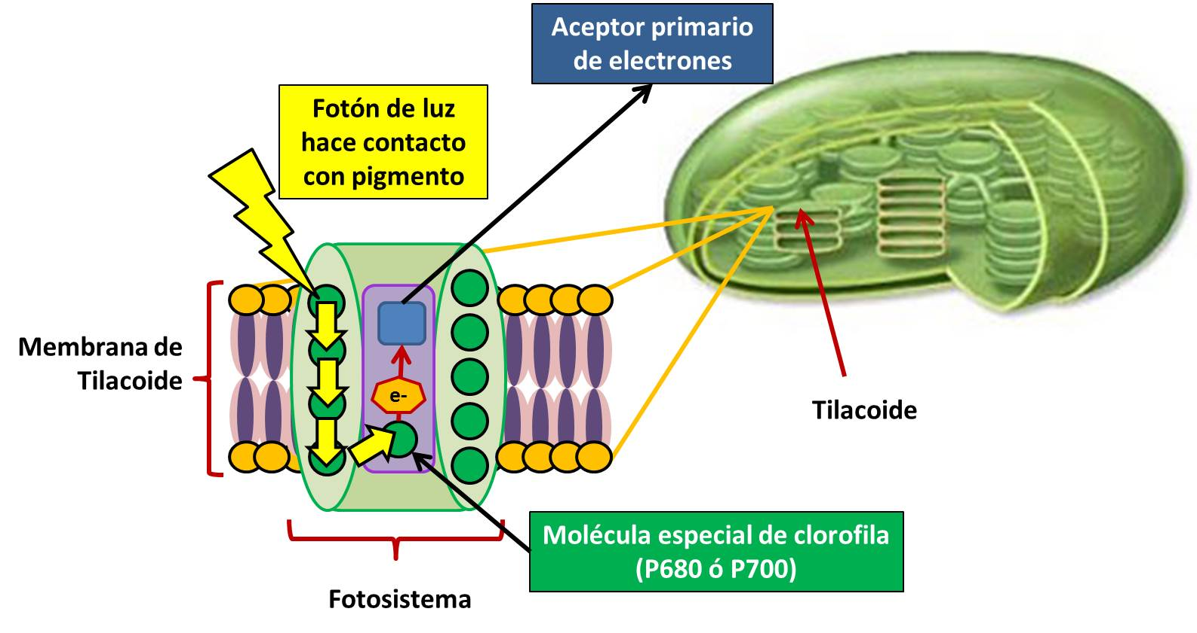

Figure 1: [1] Guillermo Estefani, April 2013.

Chlorophyll is a pigment found in all organisms that have chloroplasts in their cellular structure, being essential in the process of photosynthesis - (chemical process by which organic matter (sunlight) is converted into organic/energy) in this group are plants, cyanobacteria, and some groups of protists.

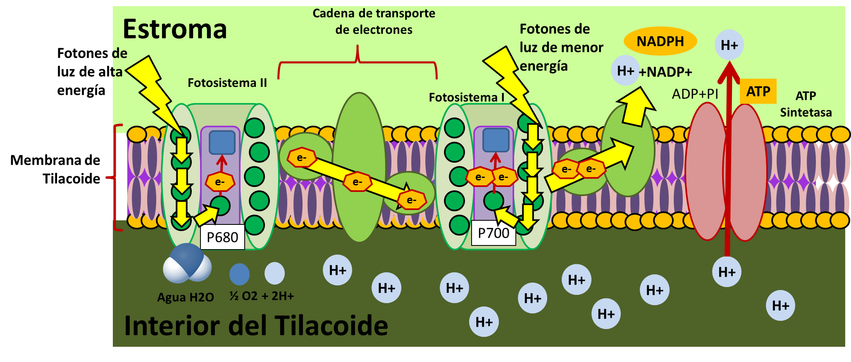

Figure 2: [1] Guillermo Estefani, April 2013.

### CHLOROPHYLL EXTRACTION.

1. Cut Spinacia oleracea leaves (spinach) and macerate them until a homogeneous texture is obtained.

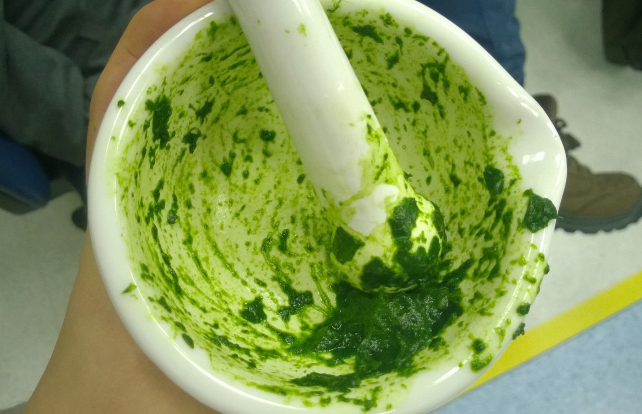

Figure 3: Macerated spinach in mortar.

1. Add 1.5 ml of the solvent to be used respectively in three Eppendorf tubes, one with the NADES (Natural deep eutectic solvents) mixture, the second with alcohol, and the third with acetone.
2. Weigh 159.9 mg of macerated spinach on an analytical balance with an uncertainty of (+/-) 0.1.



Figure 4: Analytical balance with an uncertainty of (+/-) 0.1.

1. Add to each Eppendorf tube what was previously weighed with the 1.5 ml of the solvent.

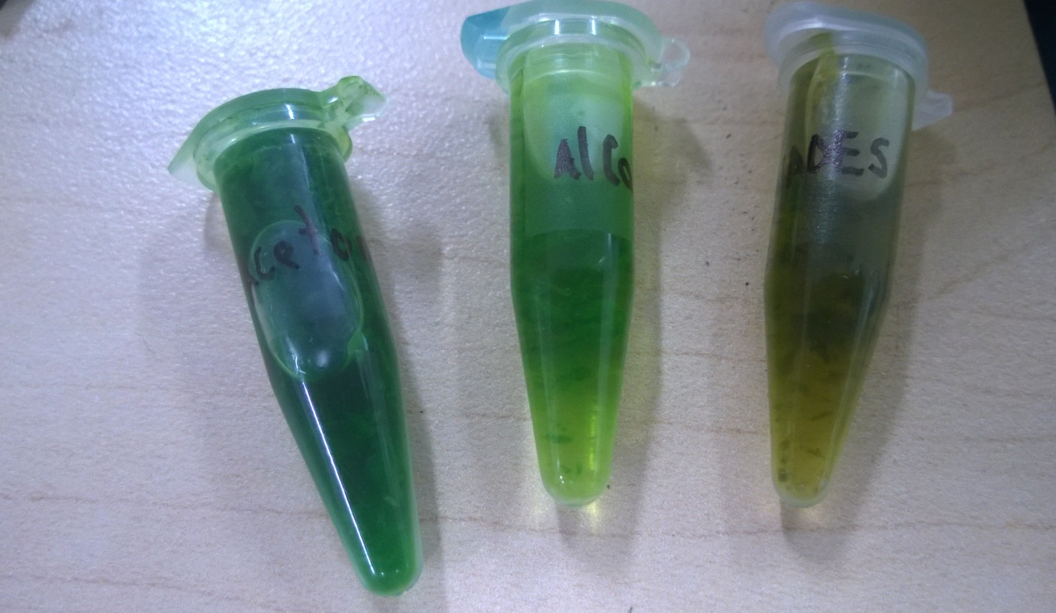

Figure 5: Mixes spinach with NADES, alcohol, and acetone.

1. Centrifuge the solution with NADES for 7 minutes, and 3 minutes for the acetone solution, the same time for the alcohol, in all cases using a speed of 5.0 RPM.



Figure 6: Centrifuge with spinach sample.

1. Filter the centrifugation of each Eppendorf tube with grade 4 filter paper (20-25 µm) preferably in test tubes.

***Note:*** The expected result of this extraction is chlorophyll, mostly chloroplasts without other organelles, thanks to centrifugation and filtration (this procedure is called chloroplast isolation).

## SPECTROMETRY MEASUREMENT PROTOCOL

Carrying out the process of numeral 3.1.1. from 1-6, use the chlorophyll extraction to carry out spectroscopy.

1. Configure the absorption spectroscopy from 400 to 700 nm (visible light spectrum) on the x-axis and from 0 to 100 on the y-axis (absorption spectrum).
2. Add a sample of the solvent in blank (Solvent alone) NADES in a new beaker.
3. Start measuring the baseline (The line obtained by the solvent alone) before absorption and perform a blank exercise to ensure that the machine is in good condition.



Figure 7: Measurement cells with samples and result on spectrophotometer.

1. Deposit the liquid obtained from the previous extraction of NADES respectively in the spectrometry beakers.
2. First, perform a comparative test between the NADES blank solvent and its extraction. Repeat the same procedure as in sections 3.1.1.1-3, but this time with acetone and its extraction, followed by alcohol and its extraction.

***Note:*** With the above and according to the obtained graph, the amount of extracted chlorophyll is known (the visible light spectrum range shows the amount of functional chlorophyll). This is compared with the graph to determine if the extraction was done correctly and if it is similar to the action spectrum of photosynthesis.



Figure 8: Chlorophyll A vs Chlorophyll B.

## PROTOCOL OF THIN-LAYER CHROMATOGRAPHY (TLC) OR CCF



Figure 9: TLC Chromatography, 2014.

TLC chromatography is a chromatography technique that uses a plate (silica gel for chromatography) to separate components using an eluent. It consists of two phases, a stationary phase and a mobile phase. The stationary phase is where what is being studied is located, by adding the sample to the gel sheet. The mobile phase is the eluent in a closed container. The process begins by submerging the stationary phase into the mobile phase, waiting for a time for the sample to run through capillarity. Then, there are two options, if it is noticed, the process is finished, otherwise, the revealing methods can be used. These can be chemical or physical. Among the chemical methods is performing a reaction with a revealing reagent, and in the physical methods, adding a fluorescent indicator absorbent (UV lamp, fluorescence).

1. Prepare the sample of the solution that will be the stationary phase to study.
2. Cut 1 cm x 5 cm from a thin silica gel chromatography sheet.
3. Draw a point centered at one end of the sheet as an indicator of the start of chromatography. Preferably with a fine-tipped pencil.
4. Immerse a capillary tube in the sample (stationary phase) and place a drop on the reference point previously drawn.
5. Fill a closed container with 5 ml of the solution (which will be the mobile phase).
6. Submerge the stationary phase in the mobile phase, making sure that the indicator point end touches the mobile phase.
7. Wait a few minutes while the mobile phase ascends by capillarity.
8. Extract the silica sheet and let it dry for a few minutes.
9. If the solvent shows the expected coloration, the chromatography has finished. Otherwise, revealing agents or a UV lamp can be used.

## 3.4 PROTOCOL OF TLC CHROMATOGRAPHY WITH NADES (NATURAL DEEP EUTECTIC SOLVENTS) FOR CHLOROPHYLL EXTRACTION.

1. Prepare a solution of lactic acid, glucose, and water (in a 5:1:3 ratio, respectively).
2. Take 10 ml of lactic acid and 6 ml of water with a graduated pipette and add both to a 50 ml beaker.
3. Weigh 3 grams of glucose on the analytical balance and add it to the mixture prepared in step 1**.**

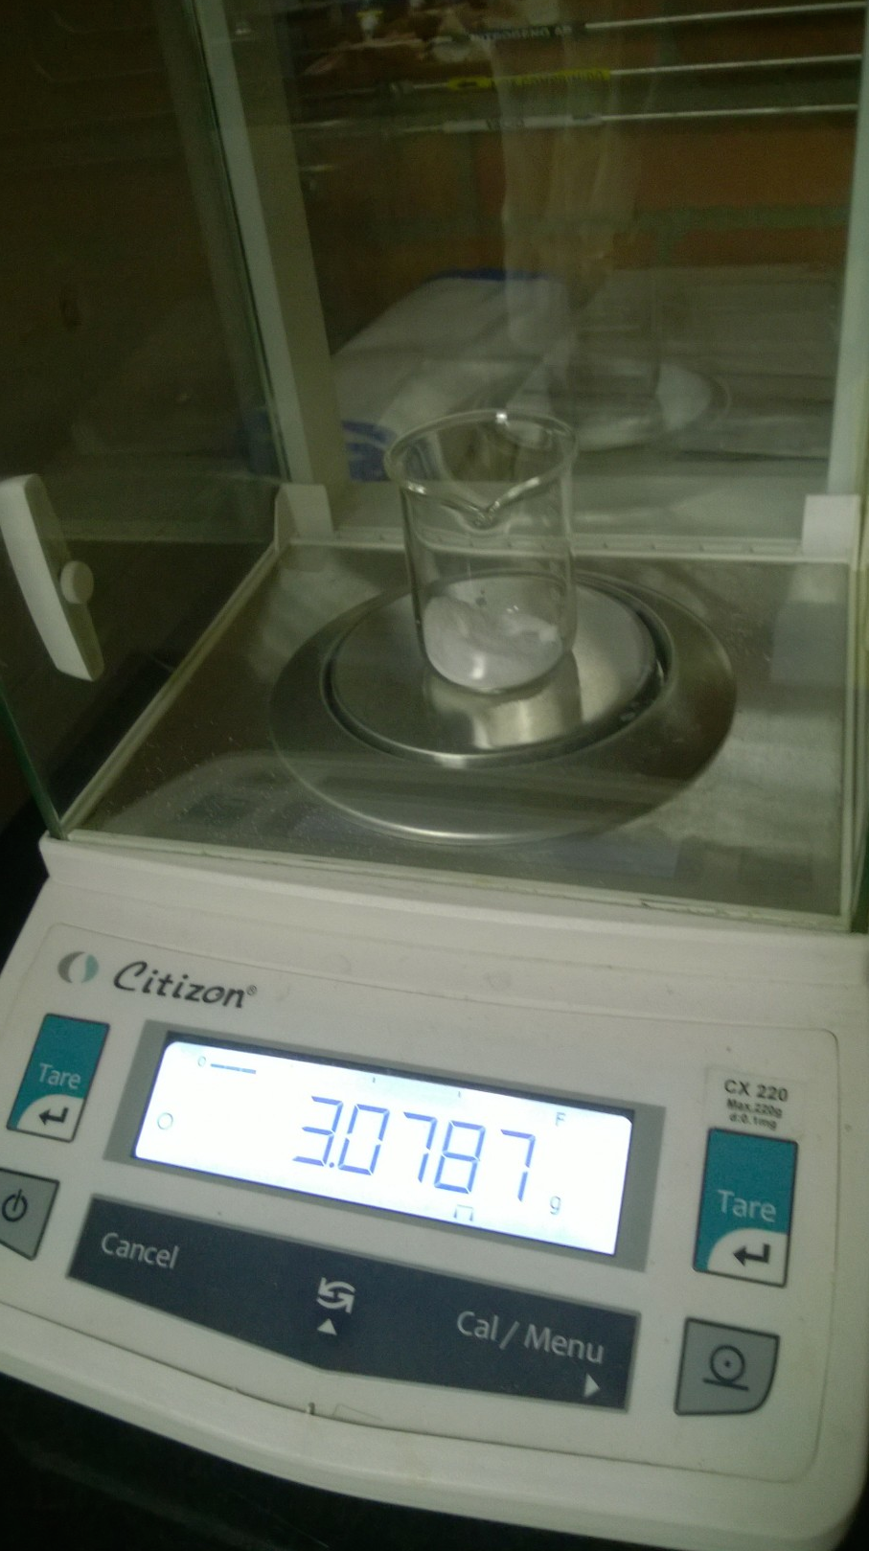

Figure 10: Uncertainty (+/-) 0.1 for greater precisión.

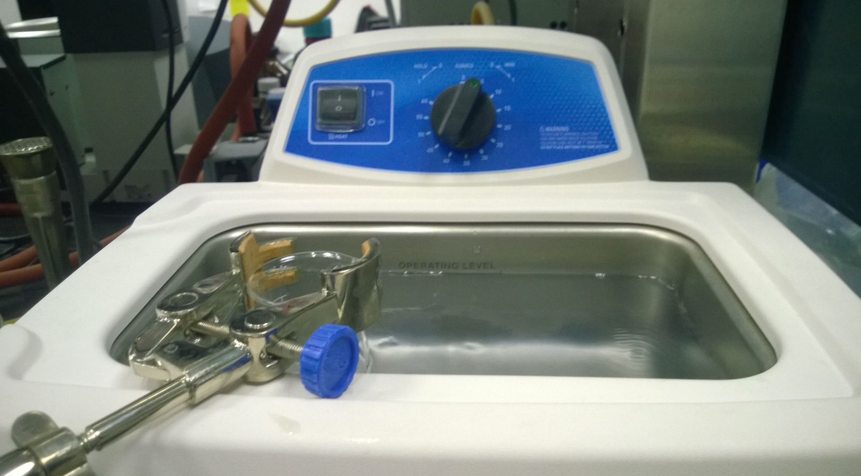

Figure 11: Ultrasonic bath.

1. As the prepared solution is viscous, two processes can be carried out depending on the ease of instruments available to the experimenter.
2. Mix with an ultrasonic agitator until all the glucose is dissolved in 20 minutes at its maximum power, thus obtaining a homogeneous solution of all components.
3. Heat the solution at a regulated temperature between 60-70 degrees Celsius on the hotplate with a magnetic stirrer at medium speed for about two hours or until a homogeneous solution is obtained.



Figure 12: Lactic acid and glucose solution in water.

1. Macerate the spinach in the mortar until a compact structure is obtained.



Figure 13: Macerated spinach.

1. Dilute the spinach extract in the prepared NADES until it functions as a solvent in the macerated extract (as shown in the photo).

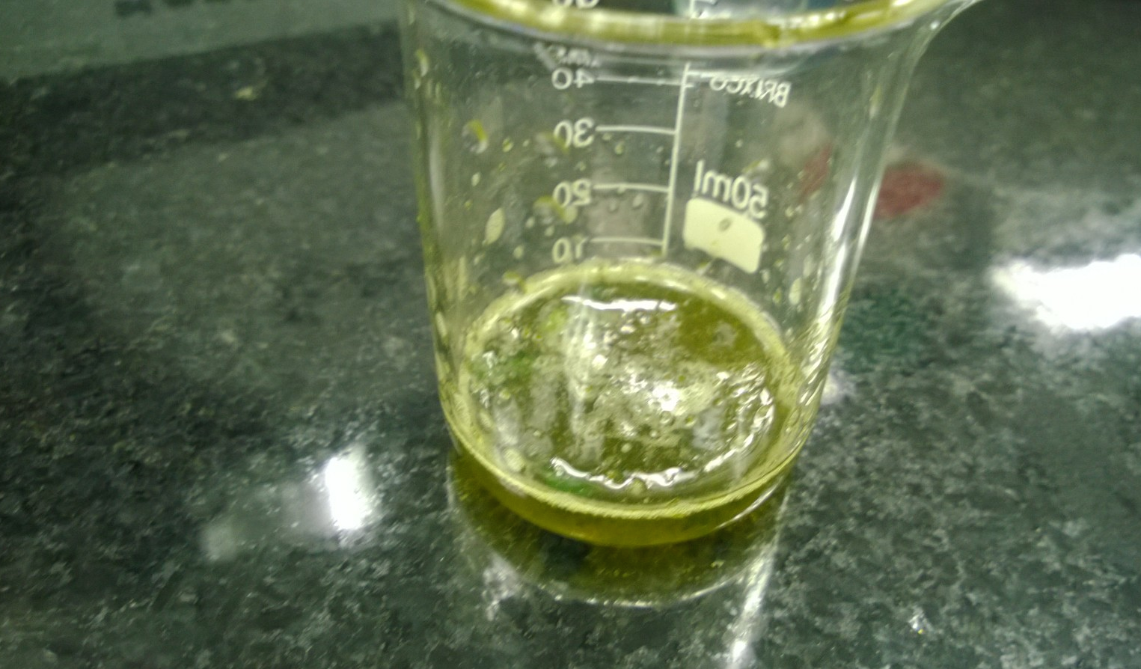

Figure 14: Diluted spinach extract in NADES.

1. Take the grade 4 filter paper (20-25 µm) and fold it as shown in the image (4).

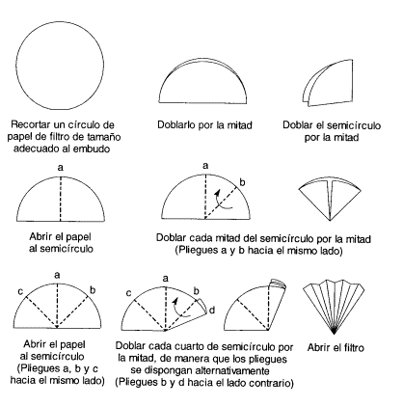

Figure 15: [2] Chemistry lab, August 2009.

1. Filter the obtained solution with the filter paper using a funnel and a universal support, until at least 5 ml of extraction is obtained.

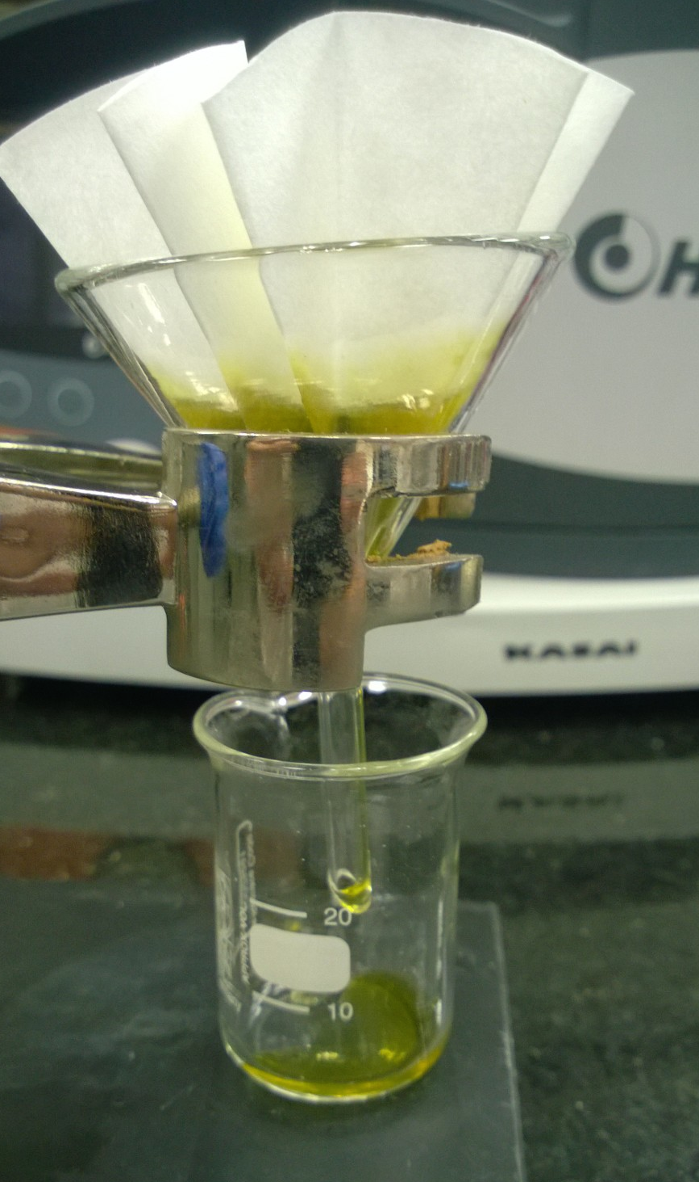

Figure 16: Filtration.

1. Cut 1cm x 5cm from a silica gel plate for thin-layer chromatography.
2. Draw a point centered at one end of the plate as a starting indicator for chromatography.
3. Dip a capillary in the chlorophyll extraction (stationary phase).

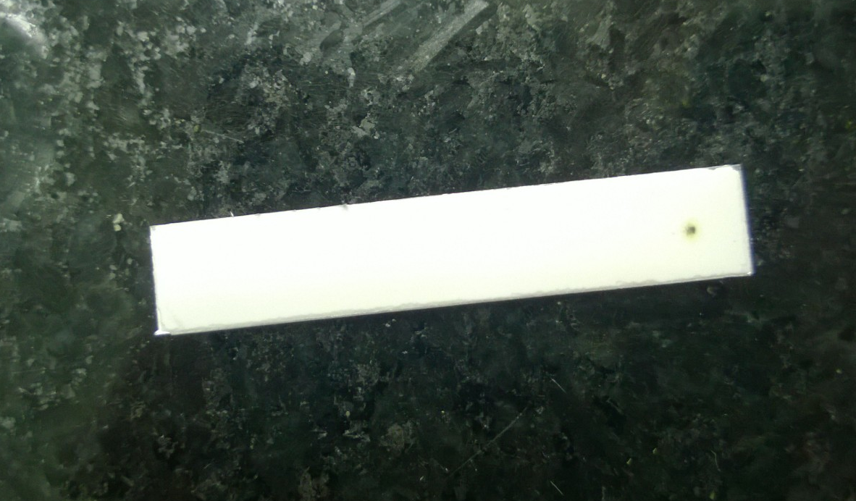

Figure 17: Indicator plate.

1. Place a drop of the extraction on the starting point (previously drawn on the silica plate).
2. Add 5 ml of petroleum ether (mobile phase) to a closed container.
3. Dip the silica plate with the stationary phase in the container with petroleum ether, with the indicator point touching the mobile phase.

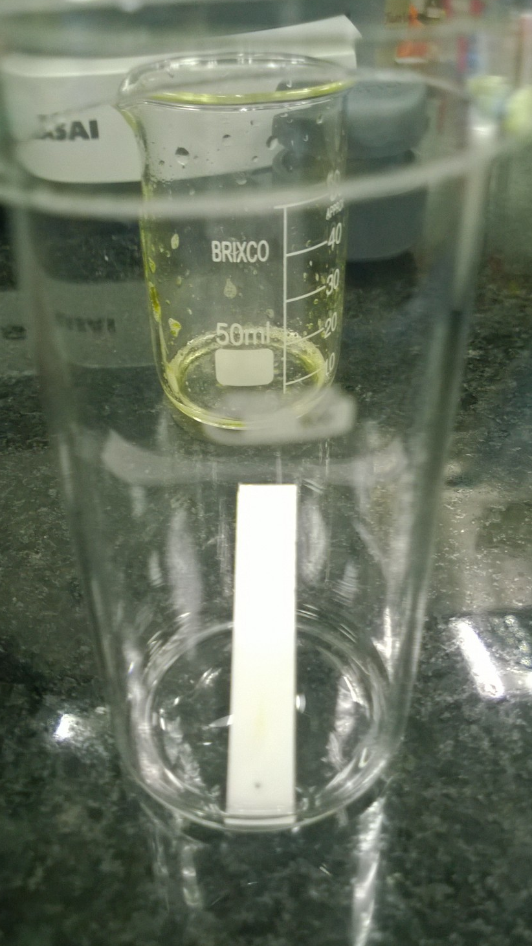

Figure 18: Submerged silica plate.

***Note:*** Leave it for a few minutes for the mobile phase to ascend by capillarity in the silica plate.

1. To ensure that the extraction and correct procedure have been achieved, reveal in a UV lamp at approximately -----nm in the light spectrum, a red color path on the sheet should be noted.
2. Immerse the sheet in a solution of H2SO4 (sulfuric acid) and vanillin (this is used as a developer, as it is not easy to see on the sheet what type of chlorophyll was extracted).

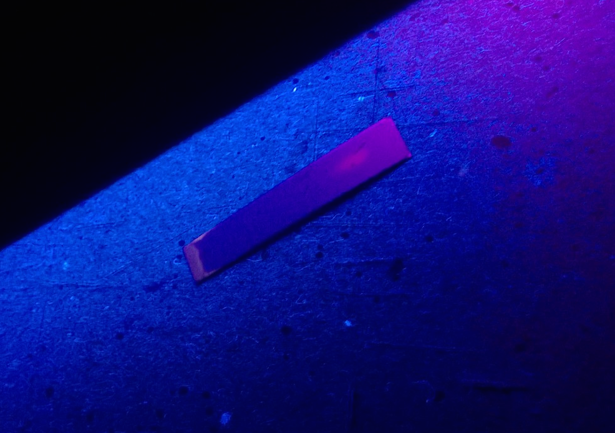

Figure 19: Sheet revealed in UV lam.

1. Allow the sheet to dry and apply some heat with the hot plate (between 50-60 degrees Celsius for 30 seconds).

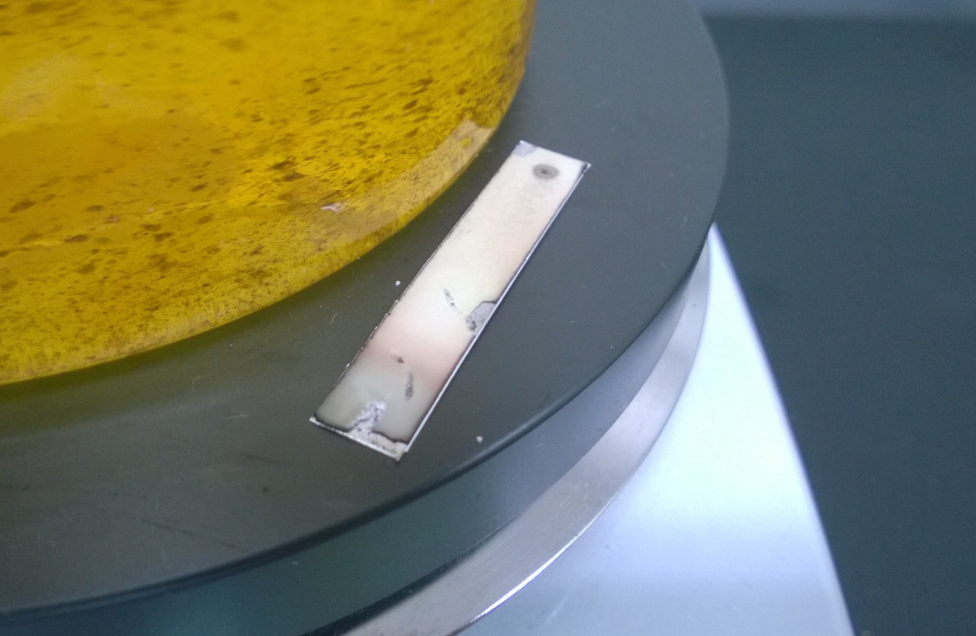

Figure 20: Sheet on drying plate.

***Note:*** Do not exceed the time and constantly monitor the temperature to avoid damaging the sample.

1. Classify based on the colors of the sample what type of chlorophyll is being extracted. (In our case, we expect to obtain type a and b, as chlorophyll is the pigment and molecule that allows the transformation of solar energy to chemical energy, these two types generally absorb a spectrum of light from which results are expected).



Figure 21: [3] Carlos Gonzalez, 2002 [4] Chlorophyll A Vs. Chlorophyll B.

## NADES PREPARATION PROTOCOL

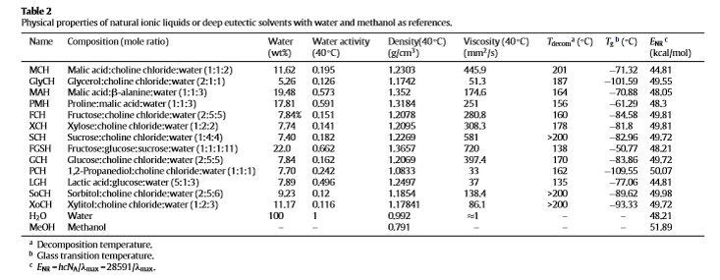

Figure 22: [5] NADES, 2013.

* Fructose
* Sucrose
* Malic acid (1:1:2)

# BIBLIOGRAPHY

1. Guillermo Estefan , ¿Qué son los cloroplastos y de que están compuestos?, abril 2013, extraído de: <http://www.artinaid.com/2013/04/que-son-los-cloroplastos-y-de-que-estan-compuestos/>
2. Laboratorio de química, Filtración, Papel filtro, agosto de 2009, extraído de: <http://laboratorio-quimico.blogspot.com/2009/08/papel-de-filtro.html>
3. Pigmentos fotosintéticos, Carlos González, Agosto 2002, blog de botánica, extraído de: <http://www.botanica.cnba.uba.ar/Trabprac/Tp6/Pigmentos.htm>
4. Clorofila A Vs. Clorofila B, Fisiología vegetal, Dirección Nacional de Innovación Académica, Universidad Nacional de Colombia, obtenido de: <http://www.virtual.unal.edu.co/cursos/ciencias/2000051/lecciones/cap02/anexo_13.htm>
5. Natural deep eutectic solvents as a new potential media for green technology, Yutao Dai, Jaap Van Spronsen, Geert-Jan Witkamp, Robert Vertpoorte, Young Hae Choi, 9 january 2013, extraído de: Analytica Chemica Acta (International Journal Devoted to All Branches of Analytical Chemistry)
6. Prácticas de química orgánica 1: Cromatografía en capa fina, noviembre 2010, obtenido de, <https://www.uam.es/gruposinv/lumila/personal/ebr/qot/leccion9/default.html>
7. Cromatografía en capa fina (tlc), 2014, extraído de:
8. <https://www.uam.es/gruposinv/lumila/personal/ebr/qot/leccion9/default.html>

# CHANGE CONTROL

|  |  |  |  |
| --- | --- | --- | --- |
| **CHANGE DESCRIPTION** | **DATE** | **VERSION** | **APPROVED BY** |
|  |  |  |  |